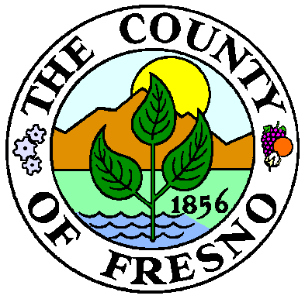


Historical Landmarks and Records Advisory Commission
Meeting Minutes
September 15, 2011

The regular meeting of the Historic Landmarks & Records Commission was held at Valley Writers, September 15, 2011.

Members present: Randy McFarland, Laurel Prysiazny, Penny Raven, Elizabeth Laval, Don Shantz, James Kus, Susan Pappas, Janice
Stevens, Pat Hunter, Roger Taylor, Stephen Barile, David Berkey, Lou Catallo, Nancy Enloe, Ethan Kytle, and John Baltierra.

Members absent: Bud Olson.

Members of the public: Karen Coletti.

- Call to Order: Chairman Randy McFarland.

- Welcome to Commissioners and Visitors: Chairman McFarland.

- Adoption of Agenda. Approved as presented.

- Approval of Minutes.

- Moved: Barile; Seconded: Shantz.

- Comments from the Public: None.

- Election of Officers: Chairman McFarland turned the gavel over to Secretary, Laurel Prysiazny who called for nominations of Chairman.

  - Moved: Randy McFarland serve as chair. Baltierra. Seconded: Kytle.
  - Moved: Roger Taylor serve as vice-chair. Pappas. Seconded: Kytle.

- Records. None

- Landmarks.

  - Courthouse Park grounds markers/memorials and sculptures. Chairman McFarland is talking with Supervisor Anderson.

  - Inventory of Historic Sites in Fresno County.

    - Suggestions for other applications. Applications sent to Huron Hotel and Church of the Brethren in Laton.
    - Jesse Morrow Mountain update. Discussion on application and Board briefing. Berkey gave an update on working to get an application presented to the Board of Supervisors.

  - Centennial Farms. None listed.

  - Centennial Businesses. Raven is working on the Fresno Business Journal application.

  - Centennial Communities. None listed.

  - Centennial Schools. Both were approved by the Board of Supervisors and certificates mailed to Bud Olson for distribution.

  - Threatened buildings in the City of Fresno. Armenian Town: Roger Taylor gave update on the five homes threatened.

  - Threatened buildings in the County of Fresno. None.

- Reports and Administrative Items.

  - Chairman’s Report: Chairman McFarland spoke of Libby’s Cannery in Selma as an historical place of interest. Discussed a field trip to Shaver Lake in early November.

  - Vice-Chairman’s Report: Vice-Chair Taylor reported on the following:
    - Update on Del Rey District. There are 17 properties in the district and he is working on notifying owners. Taylor suggested the March HLRC meeting be held in Del Rey.
    - Update on Channel 47 Book Drive.
    - Update on the Fresno Water Tower extending their hours.

  - Secretary’s Report:
    - Attendance Report: everyone is in good standing.
    - Special Collections Librarian attendance at HLRC meetings is going to be by request only.
    - Role of the Secretary
      - Style of minutes.
      - Research requests.
    - Location of future meetings.
    - Updated Roster: Attachment 3.

- Meeting Schedule.

Meeting Schedule
Date | Time | Place
November 17, 2011 | 4:00 p.m. | Valley Writers  618 5th Street

11) Adjourn 5:30 p.m.

